**Web Deployment on Tomcat Server using Jenkins CICD**

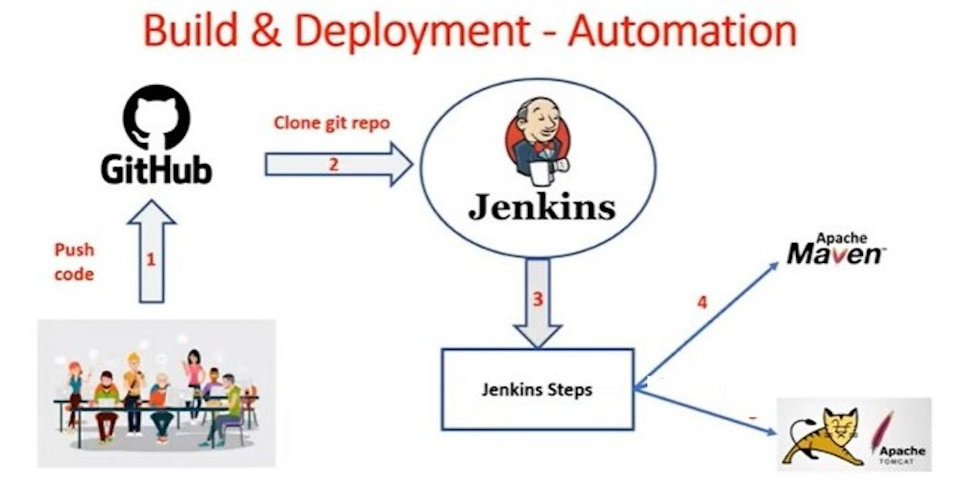

**Infrastructure Setup :**

-> Create Linux VM using EC2 in AWS cloud and install tomcat server

-> Create Linux VM using EC2 in AWS cloud and install Jenkins server

-> Clone Git Hub Repository

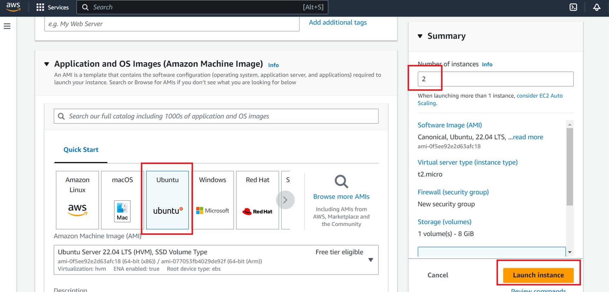

Allow port not 8080 in Security group :

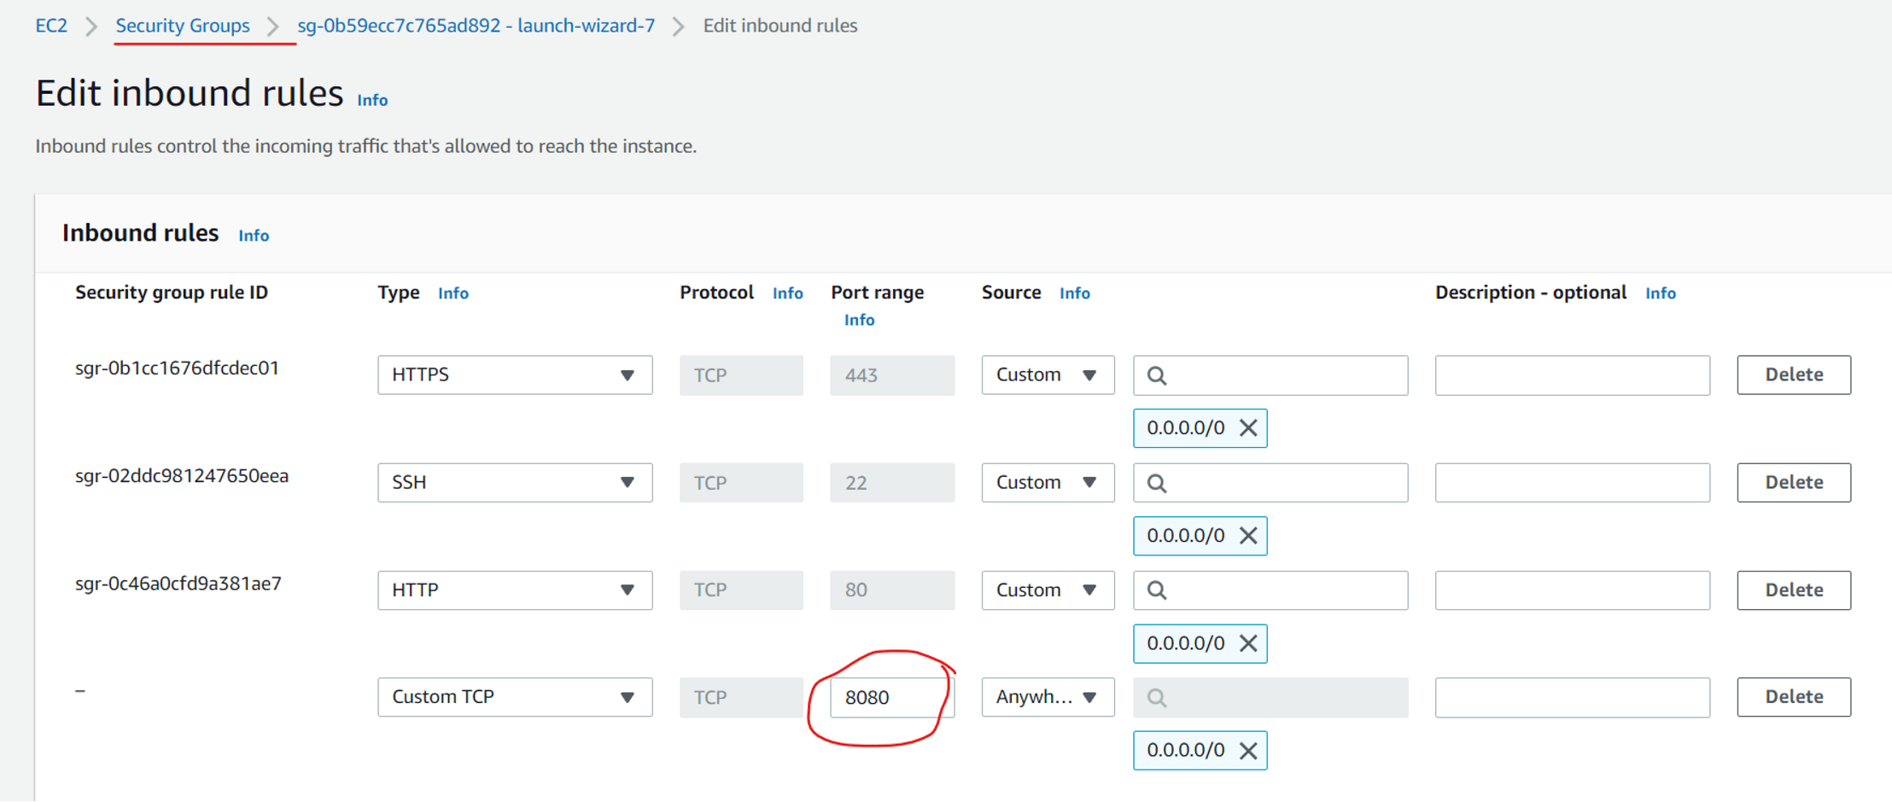

**Build & Deployment Process :**

Download project from git hub

package the project using maven

Maven will create war file

Deploy war file into tomcat (post build action)

Note: Above build & deployment process can be automated using Jenkins

Access application using URL in browser

**Jenkins Job Creation Process :**

1. Login into Jenkins

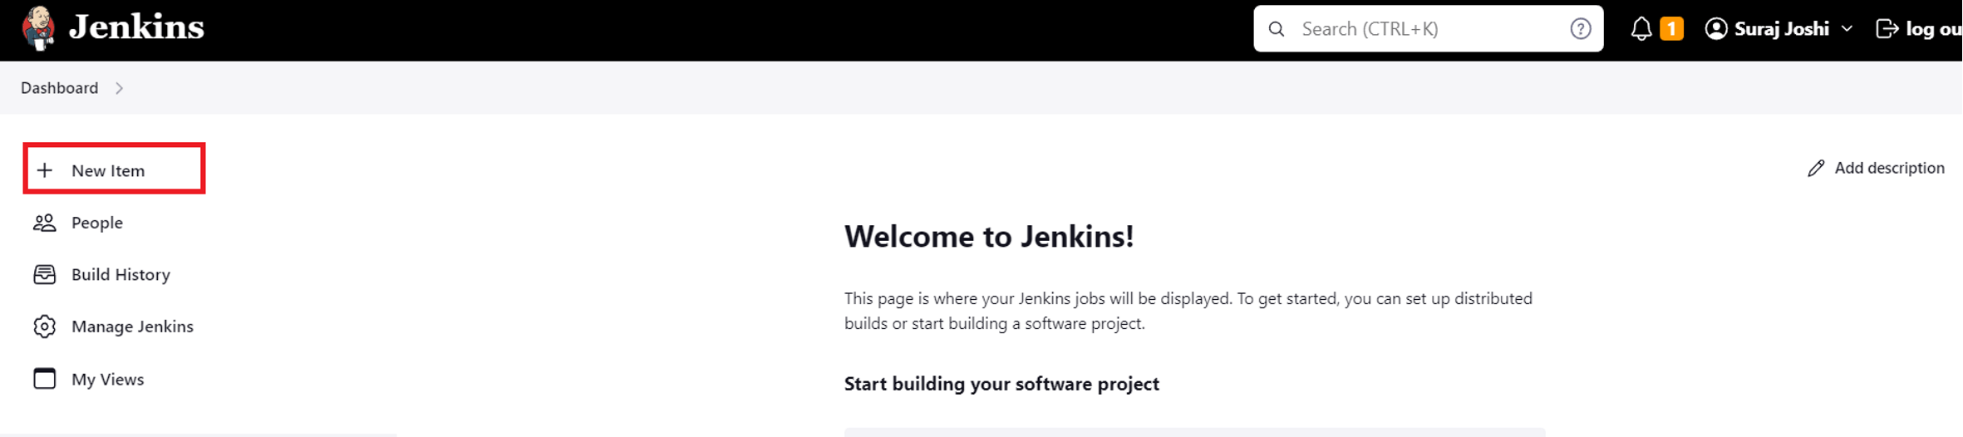

1. Configure Maven in Global Tool Configuration (Jenkins will download maven)

-> Manage Jenkins -> Global tools Configurations -> Add Maven

1. Install 'Deploy To Container' Plugin (To deploy war to tomcat server)

-> Manage Jenkins -> Manage Plugins -> Go to available tab -> search for 'Deploy To Container' plugin -> Click on install without re-start

Note: Git s/w will be available by default in Jenkins Gloabl Tools Configuration

1. Create Free Style Project

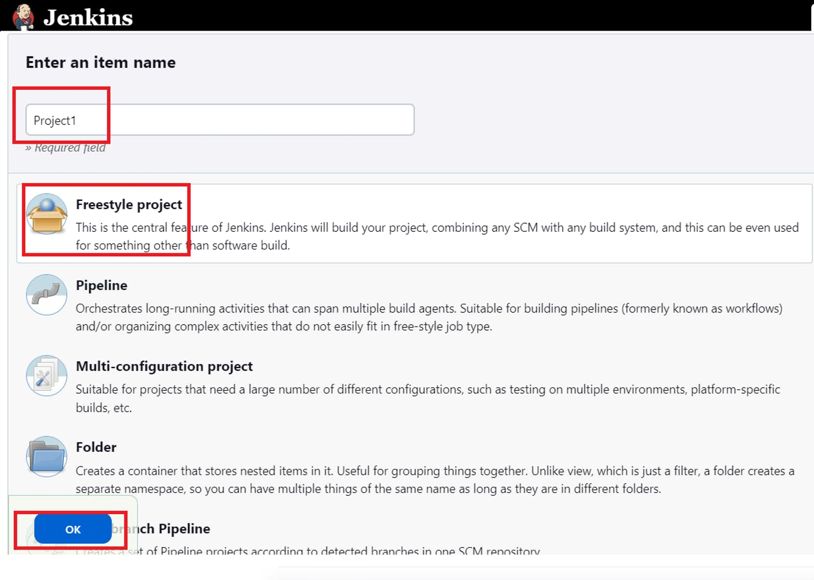

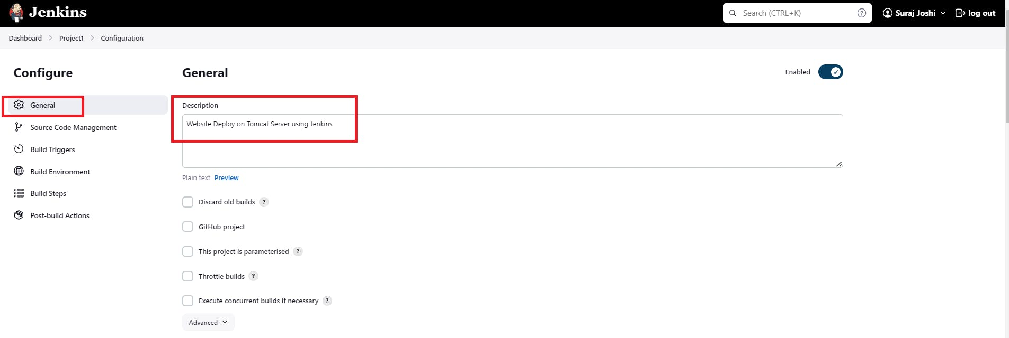

1. Enter Git Repo URL

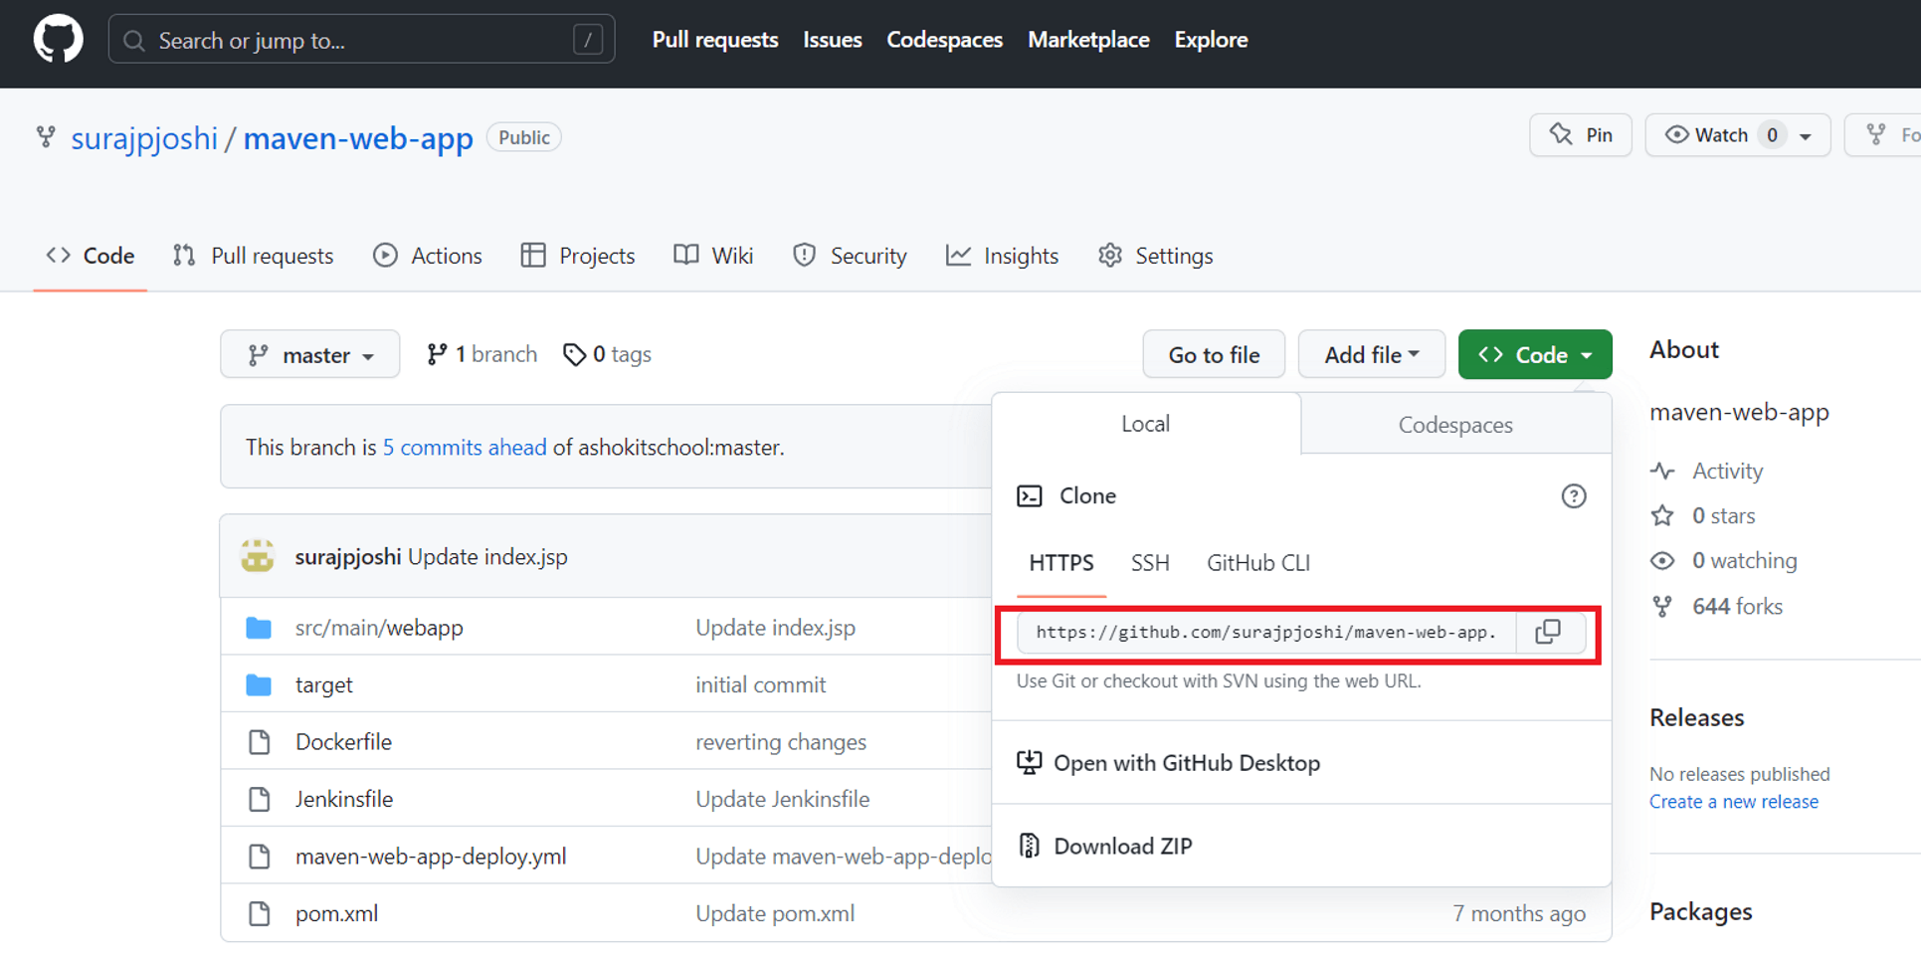

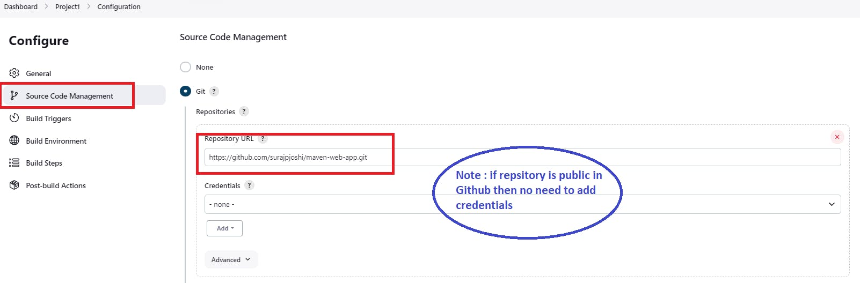

1. Build Trigger (configure Maven which is added in Global Tools and Provide Maven Goals as clean package)

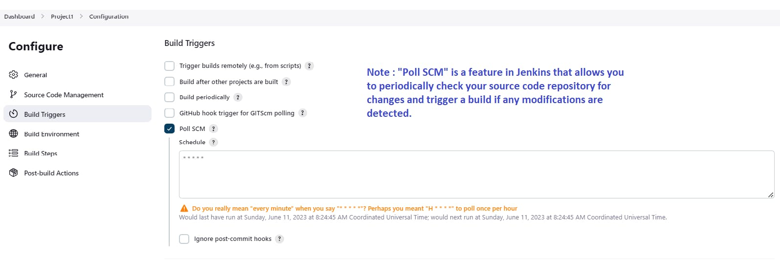

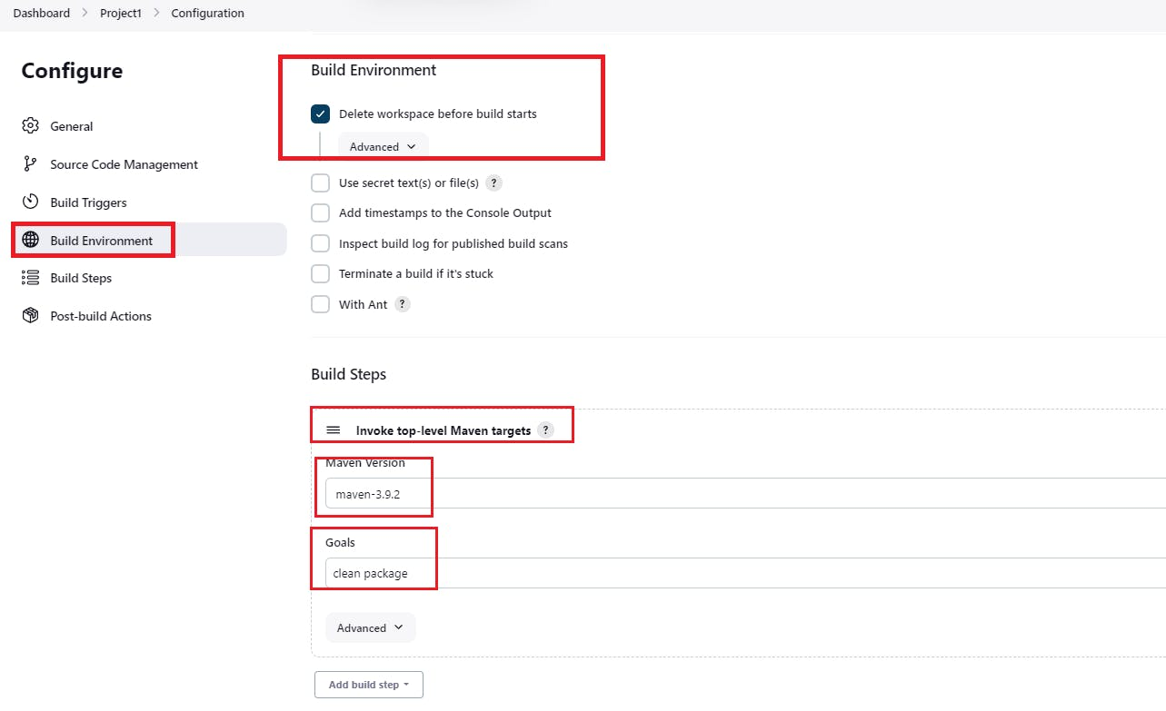

1. Add Tomcat Server in Post Build Action For deployment

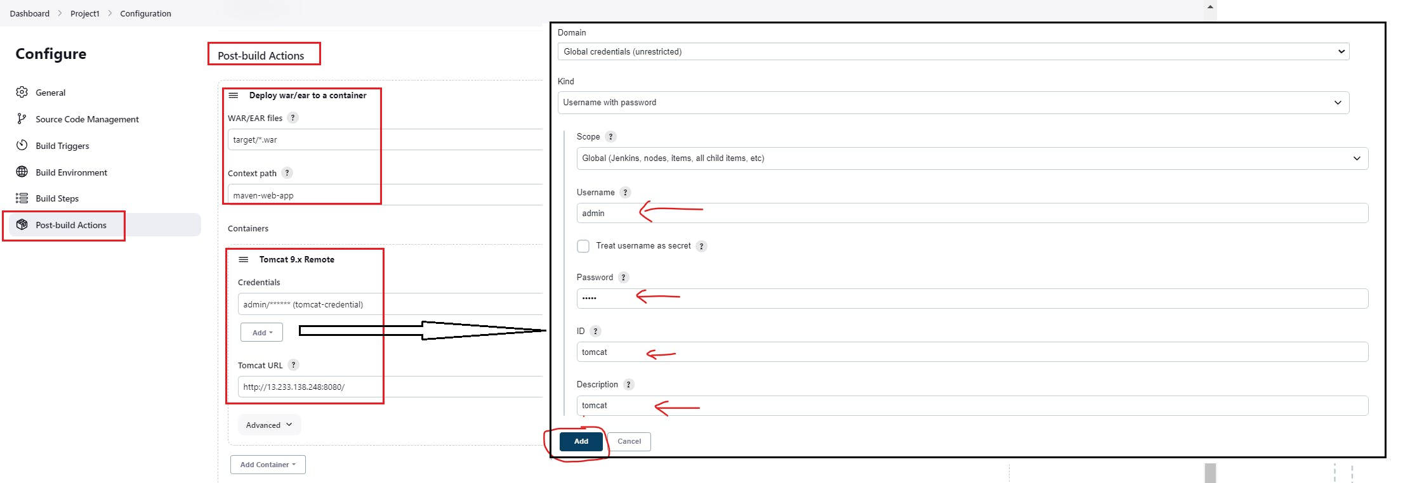

Save the Job configuration

**Run the Job :**

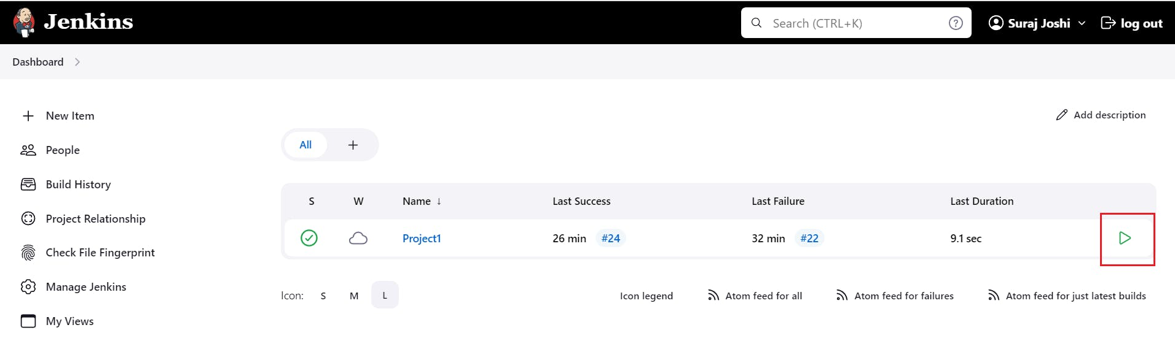

Check the Build Status :

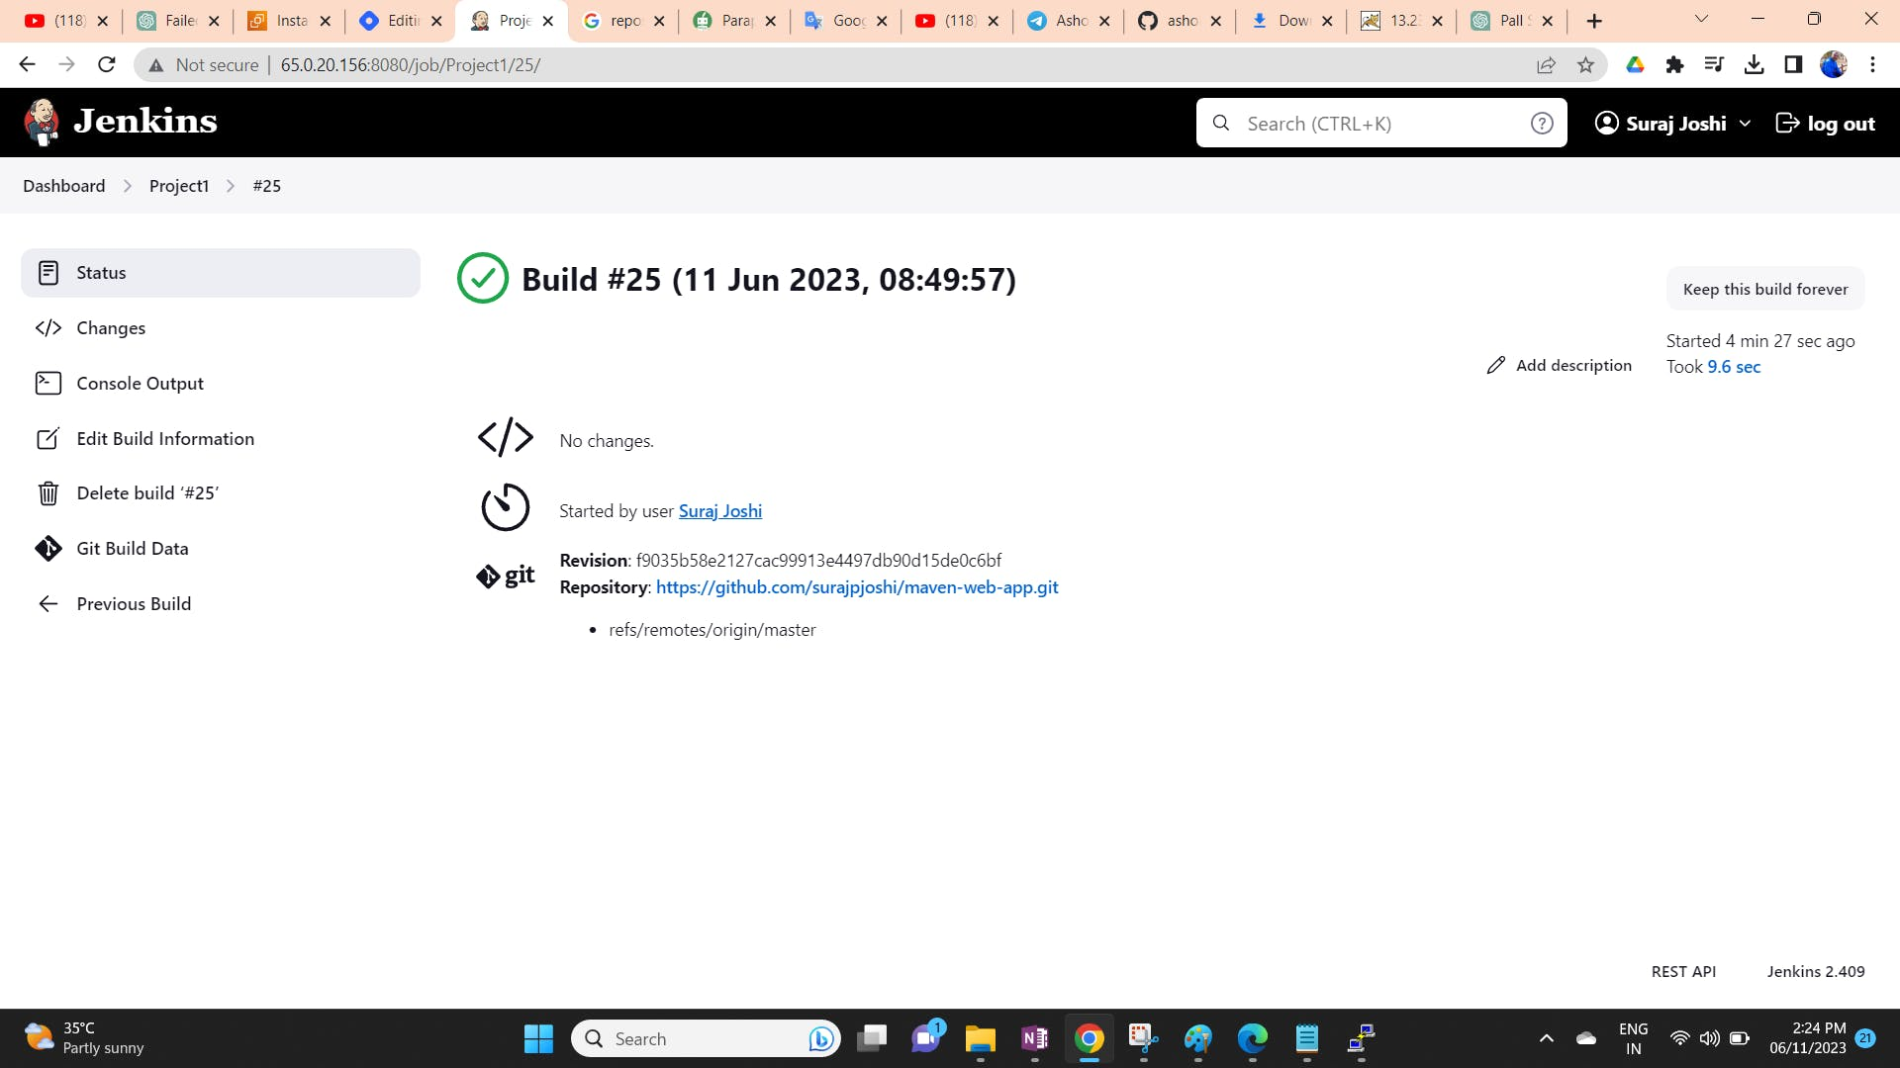

**See the Tomcat Dashboard (Application should display) and access the application**

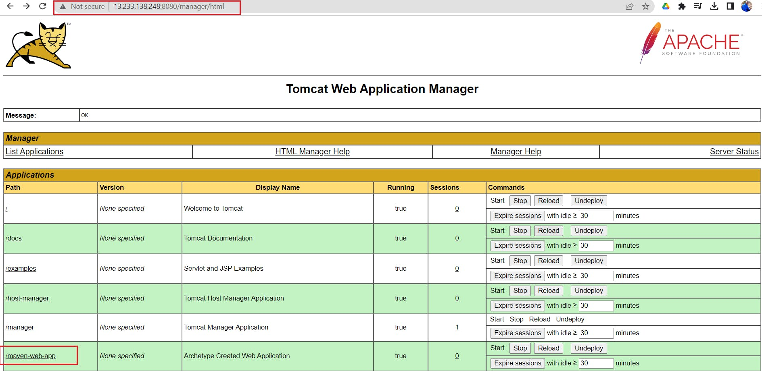

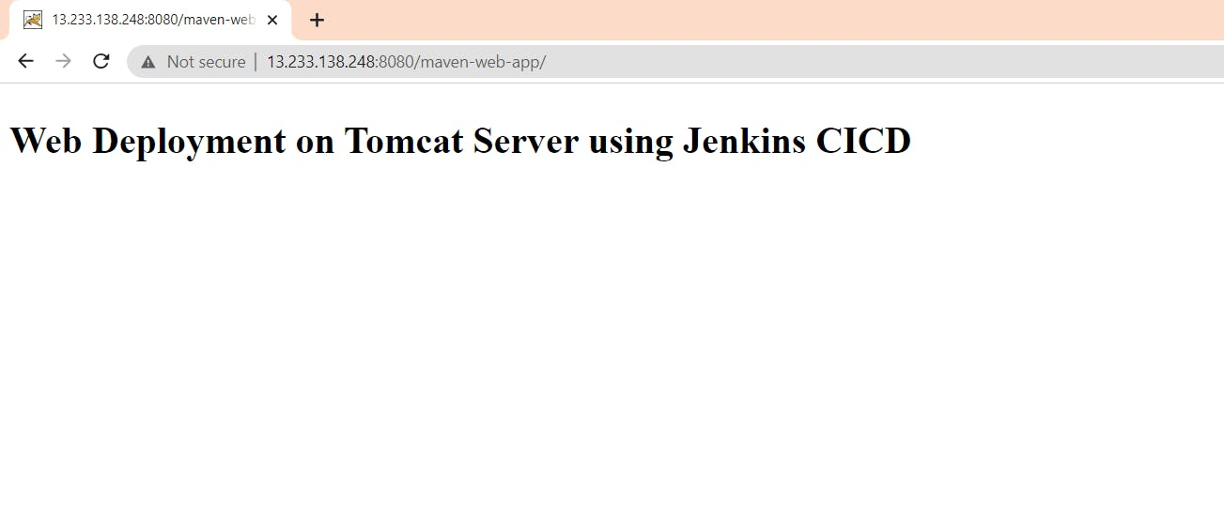

Hope this blog is useful and you can use these resources to configure the CICD pipeline. Thank you